Contributor: Deborah Caplow

Ruiz, Antonio

Born: Texcoco, State of Mexico, 1897; Died: Mexico City, 1964

Antonio Ruiz, also known as El Corzo or El Corcito, after a famous Spanish bullfighter, was during the 1920s to the1950s, primarily an easel painter. His small, jewel-like paintings, finely executed in a naïve style, show influences from Surrealism, Northern Renaissance painting, New Objectivity, and Mexican folk art. For his subjects Ruiz drew from Mexican history and politics as well as everyday Mexican life, but he often added a magical realist twist to his images. He produced very little, about four paintings per year, and only sold three works during his lifetime. A number of his paintings are now in the Museo de la Secretaría de Hacienda y Crédito Público (Museum of Ministry of Finance and Public Credit). His paintings are often satirical scenes of daily life in Mexico, sometimes with dreamlike elements, absurd juxtapositions and incongruous proportions that ally them with Surrealism. His most well-known work, El sueño de La Malinche (The Dream of La Malinche), of 1939, portrays the indigenous woman who acted as translator for Hernán Cortez and bore him a child; in this image Ruiz makes a clear reference to the Conquest of Mexico and expresses his awareness of the complexity of Mexico’s history.
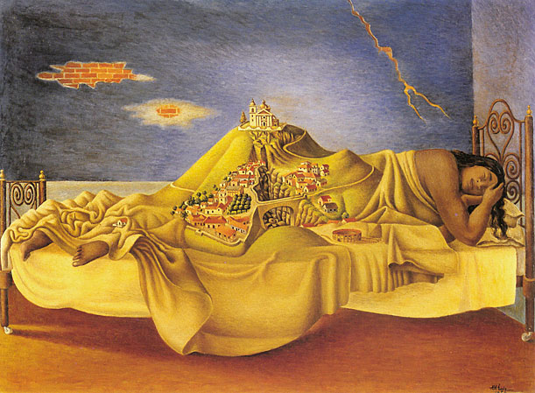
Antonio Ruiz, Sueño de la Malinche (Dream of La Malinche), 1939, oil on canvas, 11 7/8 x 15 3/4”
http://chnm.gmu.edu/wwh/modules/lesson6/images/sources/ruizlarge.jpg

Ruiz came from an educated family, with a physician father and a pianist mother, but orphaned at an early age, he had to make his own way in the world. At the age of seventeen he entered the Escuela Nacional de Artes Plasticas (National School of Fine Arts), known as the Academy of San Carlos, and studied painting and drawing there from 1914 to 1916. He was part of a generation of students that included artists Rufino Tamayo, Julio Castellanos, Leopoldo Méndez, Carlos Mérida, and Miguel Covarrubias. The teachers who most inspired him were Saturnino Herrán and Germán Gedovius. After two years at the Academy he began to study architecture and worked as a technical draftsman at the Ministry of Communications and Public Services.

He taught drawing in primary schools in Mexico City from 1921 to 1925, using the artistic theories of Adolfo Best Maugard, whose drawing method was based on Pre-Columbian designs. In 1927 he married Merced Pérez Correa with whom he had two daughters; he lived quietly with his family in the north of Mexico City for the rest of his life. From 1925 to 1927 he worked in Hollywood for Universal Pictures as a set designer, and he later designed sets in Mexico. In 1932 he was named professor at the Escuela Superior de Ingenieria y Arquitectura at the Instituto Politécnico Nacional (School of Engineering and Architecture at the National Polytechnical Institute) and became professor of scenography and perspective at the Academy of San Carlos in 1938. In 1942, with Frida Kahlo and Diego Rivera, Ruiz founded the Escuela de Pintura y Escultura (La Esmeralda) became director of the school, and also taught painting there.

Ruiz worked with Miguel Covarrubias on six murals for the Golden Gate International Exposition in San Francisco in 1939, and painted two other murals in Mexico, in 1935 for the Sindicato de Trabajadores de la Industria Cinematográfica (Union of Cinema Workers) (destroyed in 1948) and in the Edificio Souza on the Paseo de la Reforma, on the theme of Ptolemy and Copernicus. Other than these, and his many sets for films, plays and ballets, he only painted small canvases.

Painter Roberto Montenegro called his images tarjetas, or post cards, due to their small size and meticulous detail (many of them are 16½ x 14 ½ cm). In spite of their innocent appearance, his paintings make ironic, insightful comments on Mexican culture and society. El lider/orador (The Orator) of 1939 portrays a tiny man standing on a wooden chair, haranguing an audience of pumpkins, a witty reference to the demagoguery of the 1930s and the impending war. This painting and Sueño de La Malinche were included in the 1940 International Surrealist Exhibition in Mexico City. Other images, such as the 1936 Desfile (Parade) and Carrera de cintas en Texcoco (The Bicycle Race, Texcoco) of 1938, reflect Ruiz’s interest in Mexican events and celebrations. His 1932 La billetera (The Lottery Vendor) demonstrates his sympathy for the downtrodden; here a young mother carries her child in her rebozo; her brown skin and the shawl identify her as an indigenous woman. She stares despondently into space with a lottery ticket in her hand. Ruiz introduced a touch of Surrealism here; on the wall hangs an intricately detailed electrical box that resembles a small inquisitive face. Verano (Summer), 1937, is a brilliant commentary on social inequality and modernisation. In this image, a working-class couple stares at a store window display of mannequins in bathing suits. The contrast between the two worlds emphasises class and cultural divisions.

Ruiz created a few portraits: his 1923 Jesús (“Chucho”) Bribiesca, displays affinities with German Expressionism, with its distorted angular lines, simplified composition and intense distillation of personality. Ruiz’s joking Autoretrato (Self-Portrait) is a portrayal of the artist at his easel. He depicted himself as a turkey, the mirror reflects a peacock, and the painting he is creating portrays a bizarre bird collaged from brightly colored, Cubist-inspired shapes. The artist also satirised figures in the art world, as in his 1938 Serenata (Serenade), in which he depicted the composer Silvestre Revueltas, a legendary alcoholic, shirtless and disheveled, lying on the ground in a drunken stupor next to three musicians, and in his 1952 El Héroe (The Hero) a scene of the pompous inauguration of a monument, with its portraits of known personages, including Diego Rivera. These images demonstrate that while an active member of the circle of prominent Mexican artists, he stood apart from it, and from this position was free to criticize. In spite of the high quality of his work, his output was small and he remains less known than others.

References and Further Reading:

Antonio Ruiz, El Corcito, 1895-1964 (1987). Mexico City, CENEDIAP.

Debroise, O. (1984) Antonio “El Corcito” Ruiz, 1895-1964. Exhibition catalogue. Toluca, Mexico: Museo de Bellas Artes de Toluca.

Helm, M. (1941) Modern Mexican Painters New York: Harper and Brothers, 148-152 .

Mexico: Splendors of Thirty Centuries (1990). New York: Metropolitan Museum of Art, 655-660.

Ruiz, A. and R. Usigli (1966?) Exposición homenaje Antonio M. Ruiz: Museo del Palacio de Bellas Artes Mexico City: Instituto Nacional de Bellas Artes.

List of Works:

Jesús (“Chucho”) Bribiesca, 1923, oil on canvas.
La billetera (The Lottery Vendor, 1932, oil on canvas.
Verano (Summer) , 1937, oil on canvas.
Desfile (Parade), 1936, oil on canvas.
Carrera de cintas en Texcoco (The Bicycle Race, Texcoco), 1938, oil on canvas.
El lider/orador (The Orator), 1939, oil on canvas.
El sueño de La Malinche (The Dream of La Malinche), 1939, oil on canvas.
El Héroe (The Hero), 1952, oil on canvas.

